AWS DMS Replication Configuration
To create Replication instance
Name : Your desired name
Instance Class : Types of instance required
Engine Version : Default
High Availability : Select Multi-AZ or Single AZ

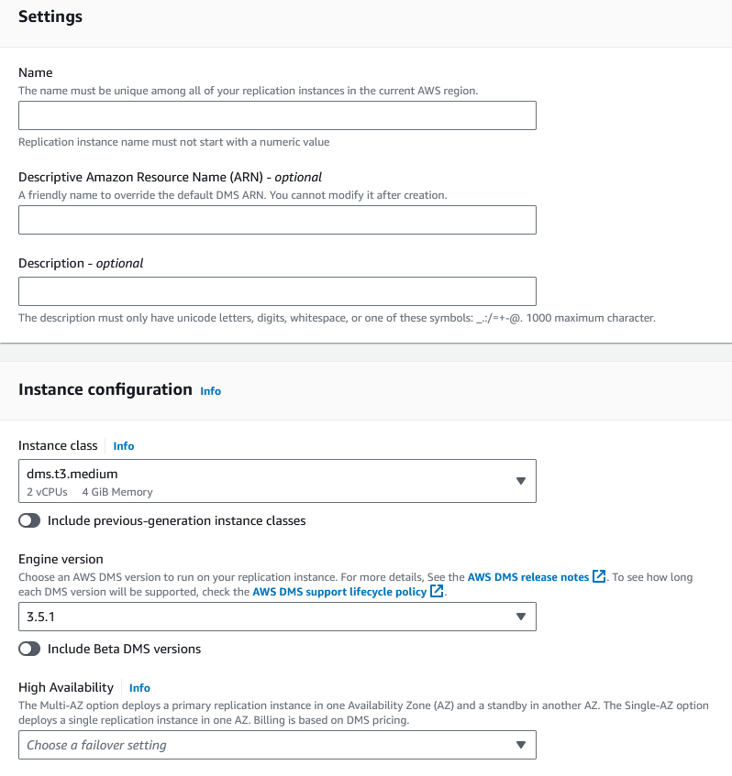

Allocated storage (GiB) : As per requirement
And select your VPC and all
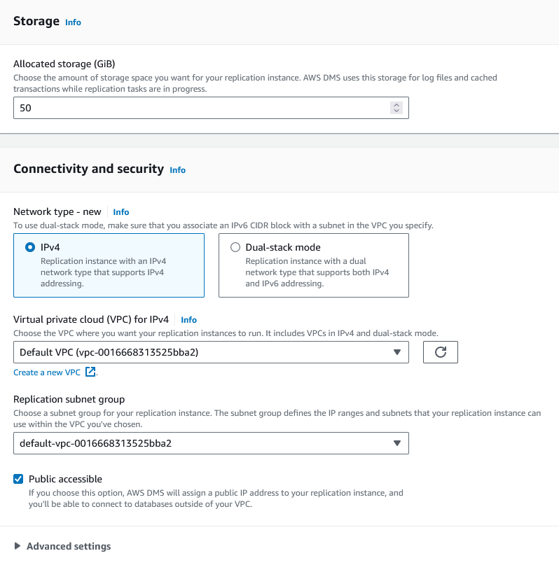
Note once you have created allow public ip or security group in your RDS security group
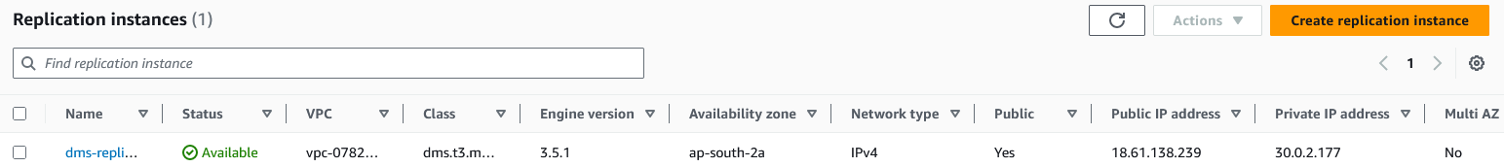

To Create Source and Target Endpoints
1st Select Source endpoint and provide endpoint name
Now select Source engine and choose your desired engine type
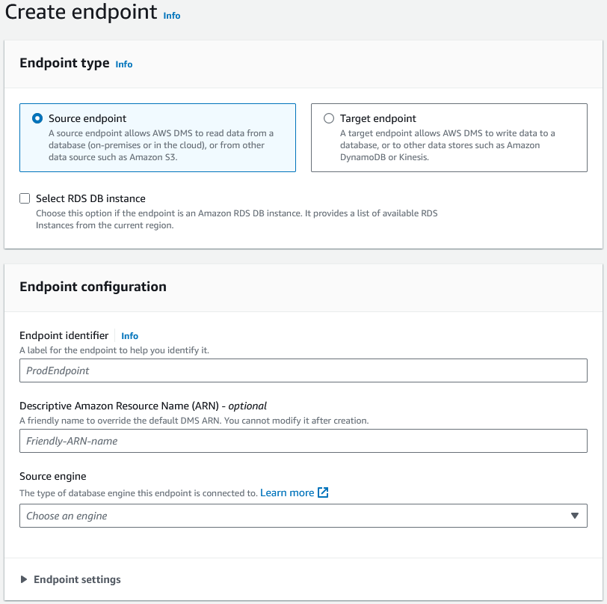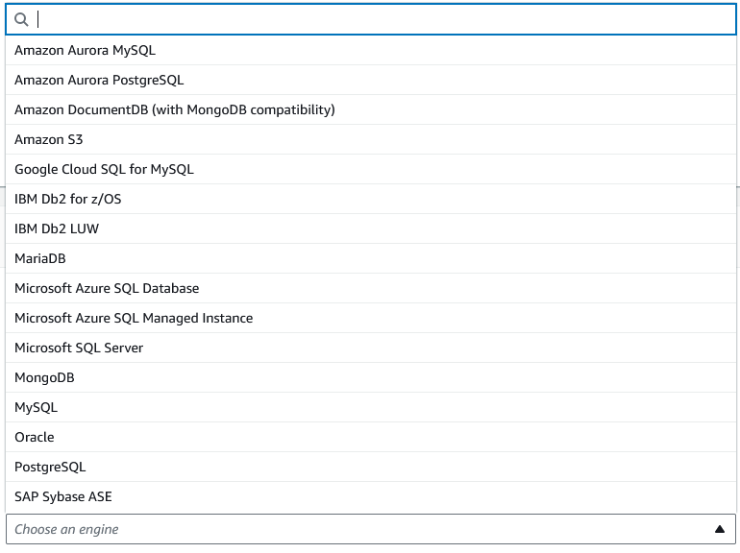

*If your source endpoint is your AWS RDS instance then choose Select RDS DB instance and select your RDS instance
Then select your VPC and Replication instance and click on test connection and if the test is successful then your endpoint is created.*
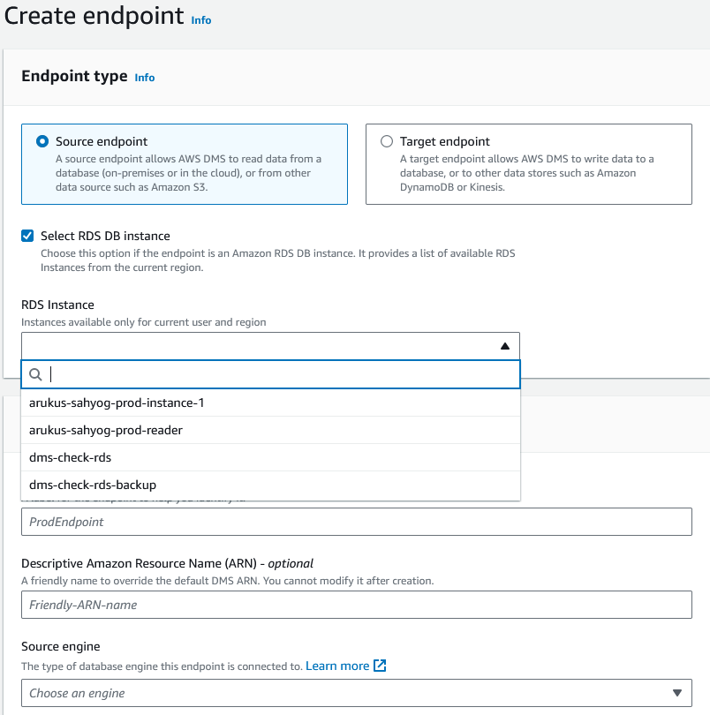Access to endpoint database : Choose Provide access information manually
Server name : Your server endpoint
Port : 3306 (your sql tcp port)
User name : db user name
Password : DB password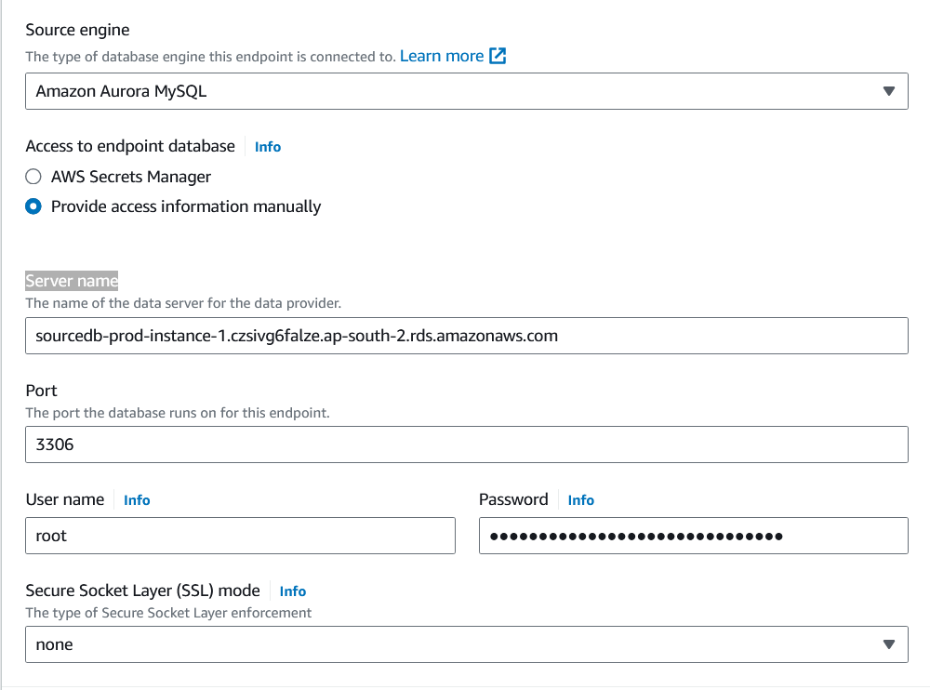
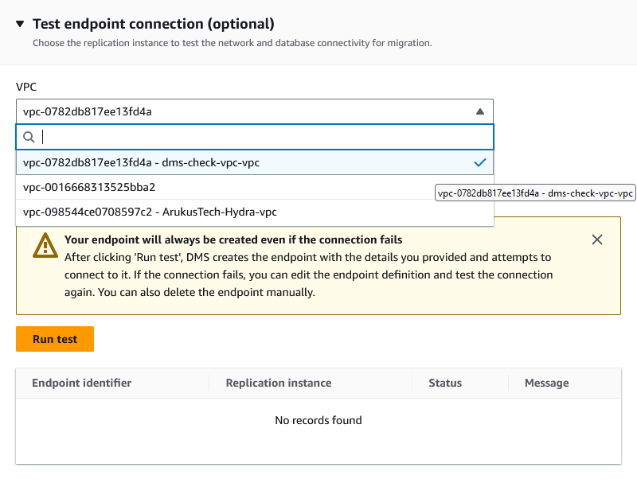
Do the same process for your target instance and test the connection status
To configure Full DB Replication or 1 table of a database go to Database migration tasks
Create new task
Task identifier = Your Task Name
Migration Type = Migrate Existing Data
Target table preparation = Truncate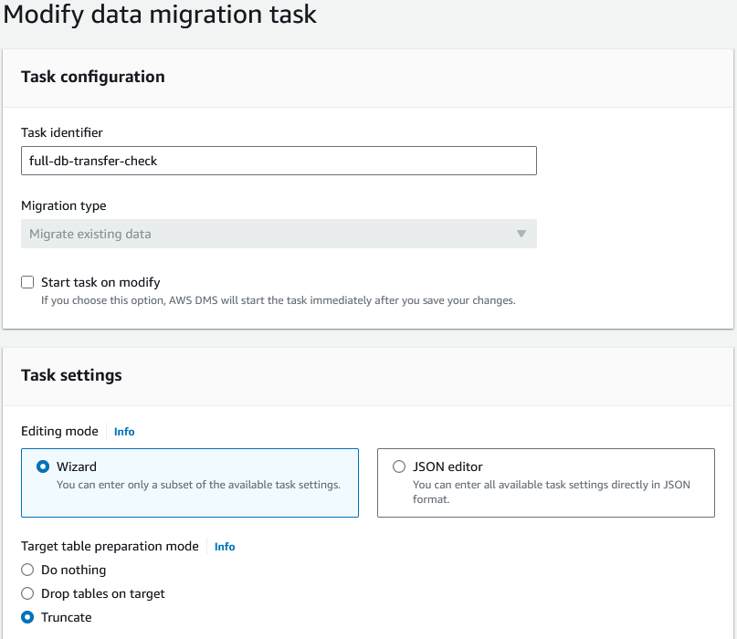

LOB column settings = Limited LOB mode
Maximum LOB size (KB) = 6400
If want to enable logs select Turn on CloudWatch Logs

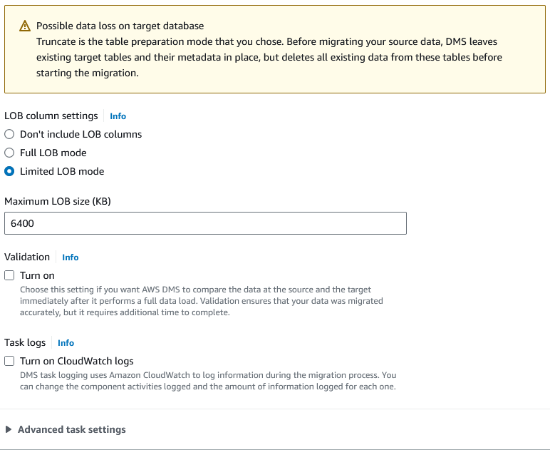
Table Mappings
Editing mode = Wizard
Select Selection rules and Add new selection rule
Schema = EnterSchema
Source name : Source Database Name
Source table name : % (For all tables) Or Name of Table of the database
Action : Include
Note : If we want to replicate multiple tables then we have to select Add new selection rule for each table
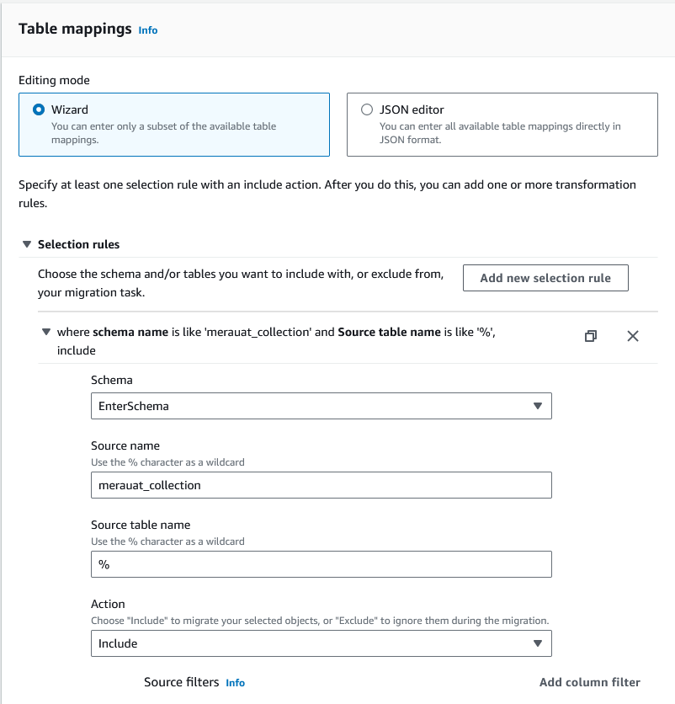
Now select Transformation rules and Add transformation rule
Rule target : schema
Source name : EnterSchema
Source name : Source Database Name
Action : rename and in blank box type Destination Database

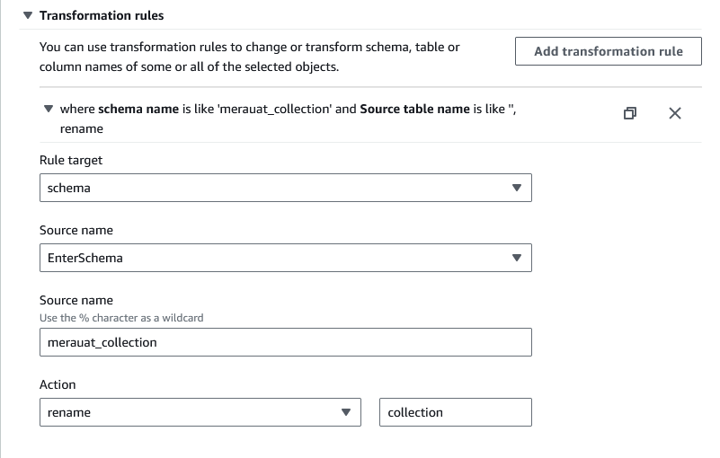
Click on Save and select Manually Start
Then select your migration task

#####=================================#####
Application Common DB to LOS DB table Tranfer::==

